## PROJECT REPORT

**ON**

## “ONLINE JOB PORTAL”

SUBMITTED BY

## Nikita Kumthekar Daivashree Kokate Shivani Shetty Jyoti Some

UNDER THE GUIDENCE OF

**DR. ROSHANI BHASKARWAR**



**DEPARTMENT OF INFORMATION TECHNOLOGY DATTA MEGHE COLLEGE OF ENGINEERING**

**SECTOR -3, AIROLI, NAVI MUMBAI- 400 708, (M.S.), INDIA**

**2022-2023**

**PROJECT REPORT ONLINE JOB PORTAL** SUBMITTED TO THE

**UNIVERSITY OF MUMBAI, MUMBAI**

**Proposed to be submitted in the partial fulfillment of requirement for the Degree of Bachelor of Engineering in Information Technology**

Submitted by

## Nikita Kumthekar Daivashree Kokate Shivani Shetty Jyoti Some

**UNDER THE GUIDENCE OF DR. ROSHANI BHASKARWAR**



**DEPARTMENT OF INFORMATION TECHNOLOGY DATTA MEGHE COLLEGE OF ENGINEERING**

**SECTOR -3, AIROLI, NAVI MUMBAI- 400 708, (M.S.), INDIA**

**2022-2023**

ii

## Datta Meghe College of Engineering

**(AICTE & Govt. of Maharashtra Recognized, Affiliated to University of Mumbai)**

# Department of Information Technology



**C E R T I F I C A T E**

**Date:**

This is to certify that, the project work embodied in this report entitled, “**ONLINE JOB PORTAL**” submitted by for the award of **Bachelor of Engineering (B.E.)** degree in the subject of **Information Technology***,* is a work carried out by them under my guidance and supervision within the institute. The work described in this project report is carried out by the concerned student/s and has not been submitted for the award of any other degree of the University of Mumbai.

Further, it is certified that the student/s was regular during the academic year and has worked under the guidance of concerned faculty until the submission of this project work at the Datta Meghe College of Engineering.

**Signature of the Guide Signature of Head of Department Signature of Principal**

iii



# DATTA MEGHE COLLEGE OF ENGINEERING

Plot no 98, Cidco, Sector-3 Post Box No.15 Airoli, Navi Mumbai-400708

**CERTIFICATE OF APPROVAL** **“ONLINE JOB PORTAL”** SUBMITTED BY

## NIKITA KUMTHEKAR DAIVASHREE KOKATE SHIVANI SHETTY JYOTI SOME

**In the partial fulfillment of the degree of B.E in “INFORMATION TECHNOLOGY” is approved.**

**Signature of Internal Examiner Signature of External Examiner**

**Signature of Head of Department Signature of Principal**

**DECLARATION BY THE CANDIDATE**

We wish to declare that the work embodied in this project report entitled “**ONLINE JOB PORTAL** forms our own contribution to the project work carried out under the guidance of **Dr. Roshani Bhaskarwar** Asst. Prof., Department of Information Technology, Datta Meghe College of Engineering, Airoli, Navi Mumbai, affiliated to University of Mumbai.

This work is carried out, written, compiled and submitted by us for the award of degree of Bachelor of Engineering in Information Technology at the University of Mumbai. This work has not been submitted for any other degree of this University or any other University.

Mumbai ––––––––––––––––––––––

Date: Signature of candidate/s

# ACKNOWLEGMENT

We would prefer to categorical our special thanks of feeling to our project guide **Dr. Roshani Bhaskarwar** who helped us in conceptualizing the project and actual building of procedures want to complete the project. We would additionally prefer to convey us thank our Head of department **Dr. Sujata Kolhe** and **Principal Dr. Sudhir D. Sawarkar** for providing us this golden chance to figure on a project like this, that helped us in doing a heap of analysis and we came to understand regarding such a large number of things.

Secondly, we would prefer to convey our family and friends who guided us throughout theproject therefore on complete our project on time.

Daivashree Kokate 24

Nikita Kumthekar 8

Shivani Shetty 51

Jyoti Some 59

# ABSTRACT

Now a day’s, it is difficult to search for jobs in proficient areas, so this online job portal is developed to provide the simple and efficient job searching. So Online Job Search Portal is a web-based and android application, which revolutionizes the way companies hire the candidates and jobseekers search for job vacancies. The application provides a flexible and easy to use environment on desktops as well as portable devices like smart phones/tablets for the users to achieve their respective objective. An employer being registered in the web site has the facility to use the services. Being an authorized user, he can publish vacancy details and can search number of Employees on the portal. Also, he can search candidates on basis of the key skill which employee provides on registration. The employer can rate the resume uploaded by the jobseeker. Candidates can search for jobs in various IT domains through advanced search capabilities. They can upload their resumes to this application which is stored for future use also. The admin controls this portal and makes the decision about companies and jobs that can access/appear in this portal. Chatbot is also provided in our website where the jobseeker can have a conversation with the bot facing any issues while registration process or also the bot can provide some tips and tricks for resume building process. These features help to build a user- friendly job portal.

**Keywords**: Companies, Feedback, Job Portal, Jobs, Results, Skills.

# LIST OF FIGURES

|  |  |  |
| --- | --- | --- |
| Fig No. | Figure name | Page No. |
| 3.2.1 | Zero Level DFD – Online Job Portal | 9 |
| 3.2.2 | First Level DFD - Online Job Portal | 10 |
| 3.2.3 | Sequence Diagram | 11 |
| 3..2.4 | Use Case Diagram | 12 |
| 4.1.1 | Key capabilities | 14 |

**LIST OF TABLES**

|  |  |  |
| --- | --- | --- |
| **Table no.** | **Tables names** | **Page no.** |
| **2.1** | **Literature Review** | **7** |

**TABLE OF CONTENTS**

|  |  |  |
| --- | --- | --- |
| **CHAPTER NO.** | **TITLE OF CHAPTER** | **PAGE NUMBER** |
|  | **ACKNOWLEDGEMENT** |  |
|  | **ABSTRACT** |  |
|  | **LIST OF FIGURES** |  |
|  | **LIST OF TABLES** |  |
| **CHAPTER 1** | **INTRODUCTION** | **1**  **2**  **2**  **3**  **4**  **5**  **5** |
| **1.1** | **Overview** |
| **1.2** | **Background** |
| **1.3** | **Problem Statement** |
| **1.4** | **Objective and Purpose** |
| **1.5** | **Scope of the project** |
| **1.6** | **Project Specifications** |
| **CHAPTER 2** | **LITERATURE REVIEW** | **7** |
| **CHPTER 3** | **METHODOLOGY** | **9**  **9**  **10**  **12**  **13** |
| **3.1** | **Tools and Technologies** |
| **3.2** | **Data Flow Diagram** |
| **3.3** | **Sequence Diagram** |
| **3.4** | **Use Case Diagram** |
| **CHAPTER 4**  **4.1** | **IMPLEMENTATION**  **Coding** | **14**  **14** |
| **CHAPTER 5**    **5.1**  **5.2** | **RESULTS & DISCUSSION**    **Data Collection (DATABASE)**  **Screenshots** | **15**  **15**  **16** |

|  |  |  |
| --- | --- | --- |
| **CHAPTER 6** | **CONCLUSION** | **22** |
| **CHAPTER 7** | **FUTURE SCOPE** | **23** |
|  | **REFERENCES** | **24** |
|  | **PAPER PUBLICATION** | **25** |

**CHAPTER 1: INTRODUCTION**

Before the invent of other various technologies and methods that were used in the past for hiring people for the job were advertisements through newspaper, television, radio etc.[1] These traditional methods were too slow, difficult and demanding for the people. This way of hiring people was not effective. Due to advanced technologies many websites emerged.

As of Indian market, there are ample opportunities for the jobs, as a greater number of educated and skilled young people are graduating each year. So, it is now the right period for the job portal sites to think out of the box, and to make most of the opportunities available. With the help of this portal the job seeker can easily submit their resume and get a lot of opportunities of the job related to their profile. And by this website the companies or employer can also find the good and well profiled resume.[2]

The online job Portal System that is to be developed provides the members with jobs information, online applying for jobs and many other facilities. This system provides services to the job applicants to search for working opportunities. Job Portal will allow job provider to establish one to one relationship with candidates. This Portal will primarily focus on the posting and management of job vacancies. This system is designed such that ultimately all vacancies will be posted online and would offer employers the facilities to post their vacancies online. It helps to review and manage the resulting applications efficiently through the web.

### OVERVIEW

Now a day, we know that searching of jobs is so difficult in proficient areas the portal developed for the providing the simple and good job searching. With the help of this portal easily the job seeker can submit their resume and get the lot of opportunity of the job related to their profile. And by this website the companies or employer can also find the good and well profiled resume.

### BACKGROUND

Before the invent of other various technologies and methods that were used in the past for hiring people for the job were advertisements through newspaper, television, radio etc.[1] These traditional methods were too slow, difficult and demanding for the people. This way of hiring people was not effective. Due to advanced technologies many websites emerged. As of Indian market, there are ample opportunities for the jobs, as a greater number of educated and skilled young people are graduating each year. So, it is now the right period for the job portal sites to think out of the box, and to make most of the opportunities available. With the help of this portal the job seeker can easily submit their resume and get a lot of opportunities of the job related to their profile. And by this website the companies or employer can also find the good and well profiled resume. The online job Portal System that is to be developed provides the members with jobs information, online applying for jobs and many other facilities. This system provides services to the job applicants to search for working opportunities. Job Portal will allow job provider to establish one to one relationship with candidates. This Portal will primarily focus on the posting and management of job vacancies. This system is designed such that ultimately all vacancies will be posted online and would offer employers the facilities to post their vacancies online. It helps to review and manage the resulting applications efficiently through the web.

### PROBLEM STATEMENT

The proposed system has been mainly designed to overcome some of the problems faced with the previous system. In previous systems they didn’t have features like chatbot, resume rating, chatbot conversational rating etc. These old job seeking methods are too slow, stressful, challenging and also lack quality. In addition, the applicants have to consider the cost and the amount of time to get the information they need, and other preparations they have to make. Finding all available job vacancies is a main step at in the job-seeking process and other problems such as:

* Most jobseekers do not have enough basic knowledge on how to select a specialized job available.
* Job seeker expectations in terms of job specifications are sometimes different from that of the company.
* Many new graduates, who become unemployed because they do not have the job skills needed by the industry, pose a big challenge for any country in the world.

### OBJECTIVE AND PURPOSE

This system aims to develop a web portal that will allow the employer companies to share relevant data and information with job aspirants, as well as to make available information on online-recruitment.

The objectives of this project are:

* To design, implement and develop a simple convenient web portal.
* To identify the needs of the companies and job seekers which will be incorporated with updated information.
* To understand the meaning, features and categories of web portals.
* To design an online recruitment system that allows employers to post their job advertisements, which job seeker can refer to, when looking for jobs. This job portal can capture job requirements based on industry needs.

### SCOPE OF THE PROJECT

There are many applications exists on online job portal but they all are not fulfilled all requirements. We proposed an application which provides information of all the job requirements for the job seekers to find a dream job. This project is aimed at developing and central recruitment process system for the freshers to find a particular job of their choice and it depends on the skills. In our job portal, we have all facilities like job filtering, chatbot for tips and tricks to make a resume and upload resume , emergency services, feedback, links to different big companies, etc. With the advancement of technology mobile devices have made it easier to access this all facilities into single application which we have developed.

### PROJECT SPECIFICATIONS

There are some key features in this Online Job Portal website. The modules are below:-

### ADMIN

Django provides the admin login. The admin module provides various functionalities. The admin users are responsible for activating and deactivating the employer accounts. In addition, Admin users can view the list of employers registered with the application.

### EMPLOYER

Employer users will be able to perform functions such as registering with the application and creating an account by providing the details of Employer Name, Employer Code, Address, Company Email, Mobile Number, Login Name. Also, Passwords that are stored in the Employer table of MySQL database. Once the account is activated, this module allows employers to post jobs summarizing responsibilities and expected skills that will be saved in the Posted Jobs table of MySQL database. The employer will also be given privileges to activate or deactivate jobs. He/she can view the list of job postings that are active. He/she can also view the applicant details that have applied for a particular job posting. The employer will be able to view reviews provided by the jobseeker.

### 

The Jobseeker users will be able to perform functions such as registering with the application and creating an account by providing the details of First Name, Last Name, E-mail, Password, Mobile Number, Primary Skill and Experience that are stored in the Jobseeker table of MySQL database. Once the account is activated, jobseekers can search, view and apply for active job

openings. All the applied jobs details are stored in the applied jobs tables of MySQL database. The applicants can also write/update reviews for the companies.

### FILTERS FOR DIFFERENT JOBS

In the Online Job Portal System, after successfully registering and login procedure, the system will help the user to create an account on the portal. With the help of filtering process, the user will get to search any parameter like job post, or particular location in the search box on the dashboard page on the portal.

### APPLICATION TO COMPANY

After applying to the particular company, the respected message will be shown to the user whether the application to the company is successful or not. This feature enables the user to apply and confirm the application to the particular company or organization.

### RESUME UPLOADING AND SAVING

While applying to the particular company the company asks to upload the resume of the candidate to the user. In the Online Job Portal, a user can upload their resume in doc, pdf, or jpg format also. And the uploaded resume gets saved on the system. The employer can also save the resume for the future use.

### RESUME RATING

As the jobseeker registers in our portal, they can start uploading their resumes for the recruitment such that the employer goes through their resumes thoroughly eventually if any employer likes or dislikes the employee’s resume, they can rate the resume and also can write a comment regarding the same.

### CHATBOT

Here we provide a chat bot feature where the applicant can able to chat with the bot such that it can give some of the guidance for the process. example guidance for resume building, applying for different jobs. The bot can provide tips and tricks for resume building process. Which will help the jobseeker for the recruitment in the future.

## CHAPTER 2: LITERATURE REVIEW

In the age of technology, the Internet has become the main source of information for jobseekers. Large corporations, Institutions, and universities include information on career Prospects on their websites. According to a survey, 70% of the workforce uses websites or portals on the Internet to Search for jobs in France. These websites or portals provide search engine to access information on job opportunities.

IN 2014 Marjan Mansourvar and Norizan binti Mohd Yasin published they’re in journal International Journal Of Computer Theory And Engineering with title ‘Development of a job web portal to improve education quality’ in this paper some of the findings are of enhance efficiency in job recruitment as applicants.[2] From the journal International Journal Of Innovation Research In Technology 32 in 2017 with the title ‘An Online job portal management system’ authors Keethana kopuri and team published their paper in this we find out some of the findings such as provides efficient search mechanism using dynamic query generation. From 2019 journal of 2019 Artificial Intelligence For Transforming Business And Society authors Aman Shakay , Shree ram Rauniyar and team with title ‘Smart job recruitment automation: bridging industry and university’ findings were CV creator, this component is useful for students to create their own CV.[4] In 2020 Title with ‘A data mining Approach for finding Similar job positions’ authors Ondrej pektor, Bogdon walek, Ivo martinik with findings such as automating the process of adding relevant competencies from found job ad in journal Research And Development For Innovations.

### 2.1. Table of Literature Review:

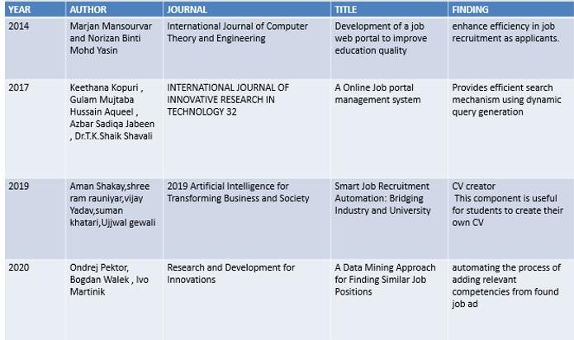

**Table 2.1: Literature Review**

## CHAPTER 3: METHODOLOGY

### TOOLS AND TECHNOLOGIES GRAPHICAL USER INTERFACE

Bootstrap &amp; CSS- this GUI is used for the background, text font , font size , font color etc. in this project we have used the bootstrap for customizing the architecture it’s a free, open-source front-end development for the website.

### DATABASE

Sqlite3- for database we have used SQLITE database in that it helps to create small, fast, self- contained, high reliable and fully featured. We have used the DB BROWSER app to view the sql query and create more tables and details about the uploaded resume.

### SOFTWARE/PROGRAMMING INFORMATION

Framework:

Django Programming Language: Python 3.10 Interpreter: Visual Studio Code

### DATA FLOW DIAGRAM

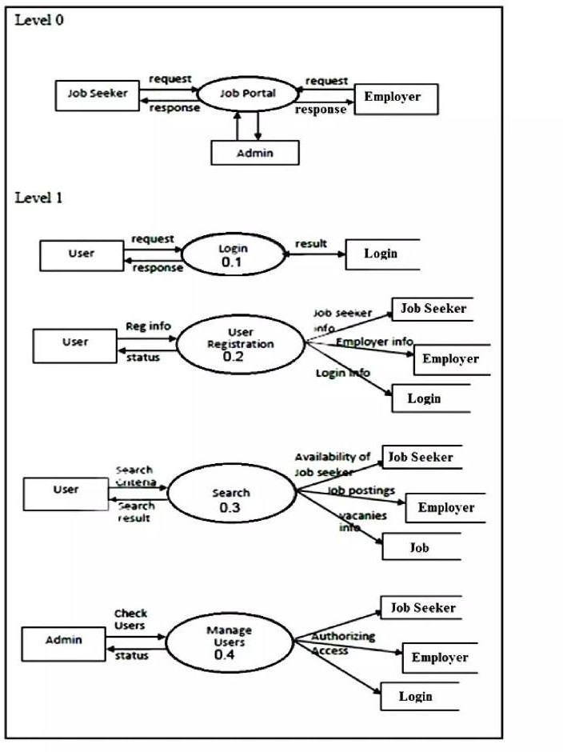

**Fig 3.2.1** **Zero Level DFD**

Figure 3.2.1 DFD level 0 is also called as a Context Diagram. It is a basic overview of the whole Online Job Portal that is being analyzed or modeled. Job seeker request for the job or apply for the job that is showed with an arrow. Same goes for the employee of the company.

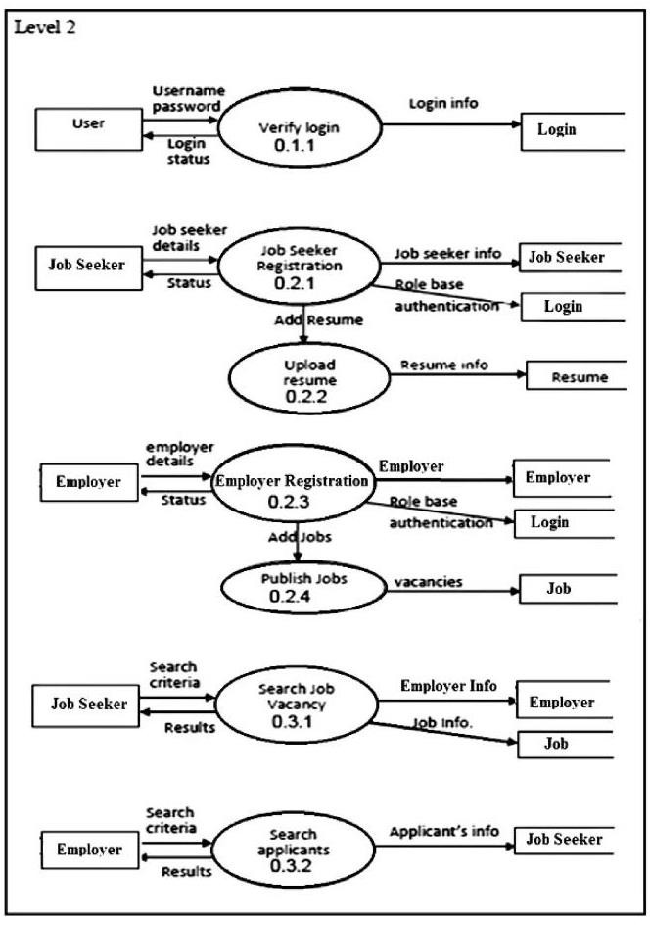

### Fig 3.2.2 First Level DFD

Figure 3.2.2 DFD, the single working process from context diagram i.e level 0 DFD is broken down into sub-processes. Sub process here are users, job seekers and employees, whose functions are showed with more arrows and in more depth.

### SEQUENCE DIAGRAM

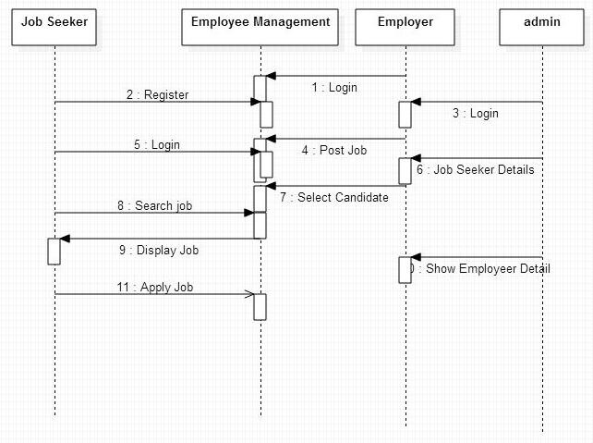

**Fig 3.2.3 Sequence Diagram**

In Figure 3.2.3 A Sequence diagram is a type of interaction diagram as it describes how and what order of objects works together. In the above diagram the connections and order is shown of the objects like job-seeker, employer, etc. First job seeker creates an account by login and then registering. Same for the employees, then they process further like searching and applying for the jobs , and posting jobs.

### USE CASE DIAGRAM

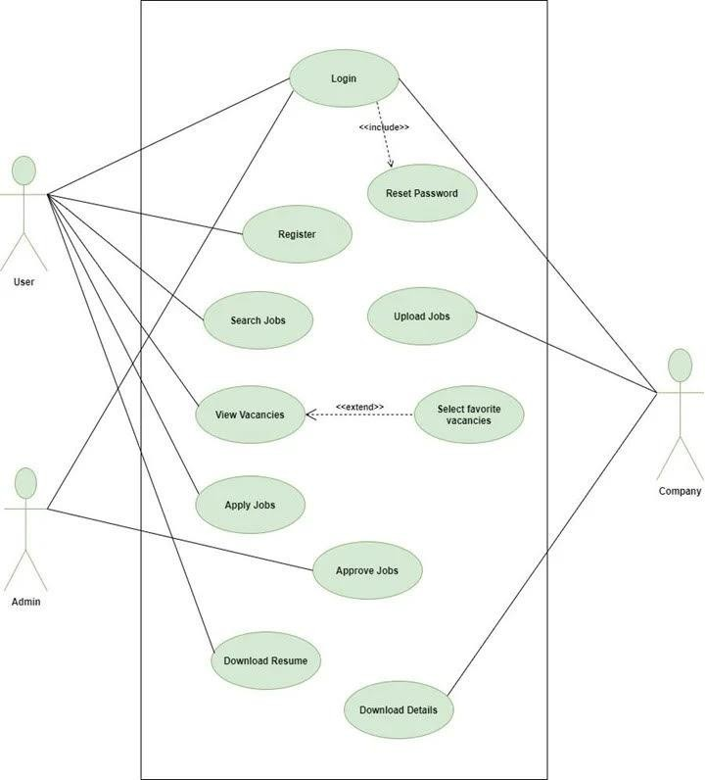

**Figure 3.2.4 Use-Case Diagram**

Figure 3.2.4 A use case diagram is a graphical depiction of a users possible interactions with a system. It shows various use cases in the circles as login or registering and different types of use cases. Here

, users, admin and company are the use cases which are main modules. And different functions performed by them are represented in the circle

## CHAPTER 4 : IMPLEMENTATION

### 4.1 CODING

**https://drive.google.com/drive/folders/1GW-q_Py17nLIYpuw19T4e52Rc2KA8shY**

## CHAPTER 5 : RESULTS AND DISCUSSION

### DATA COLLECTION (DATABASE)

SQLITE DATABASE

SQLite is an in-process library that implements a self-contained, serverless, zero-configuration, transactional SQL database engine. It is a popular choice as an embedded database for local/client storage in application software such as web browsers. It is also used in many other applications that need a lightweight, embedded database. It helps to store the data of each applicant’s entry while filling the applicant form , uploaded resume , companies name etc.

* + 1. **Key capabilities**

Online/Offline Firebase apps remain responsive when online because the Firebase Realtime Database SDK persists your data to disk. Once connectivity is reestablished, the client device receives any changes it missed, synchronizing it with the current server state.

Accessible from Client Devices

Database accessible offline with this application DB Browser SQLite

That is used to write the sql query and shows the data in a form of browse data

### SCREENSHOTS

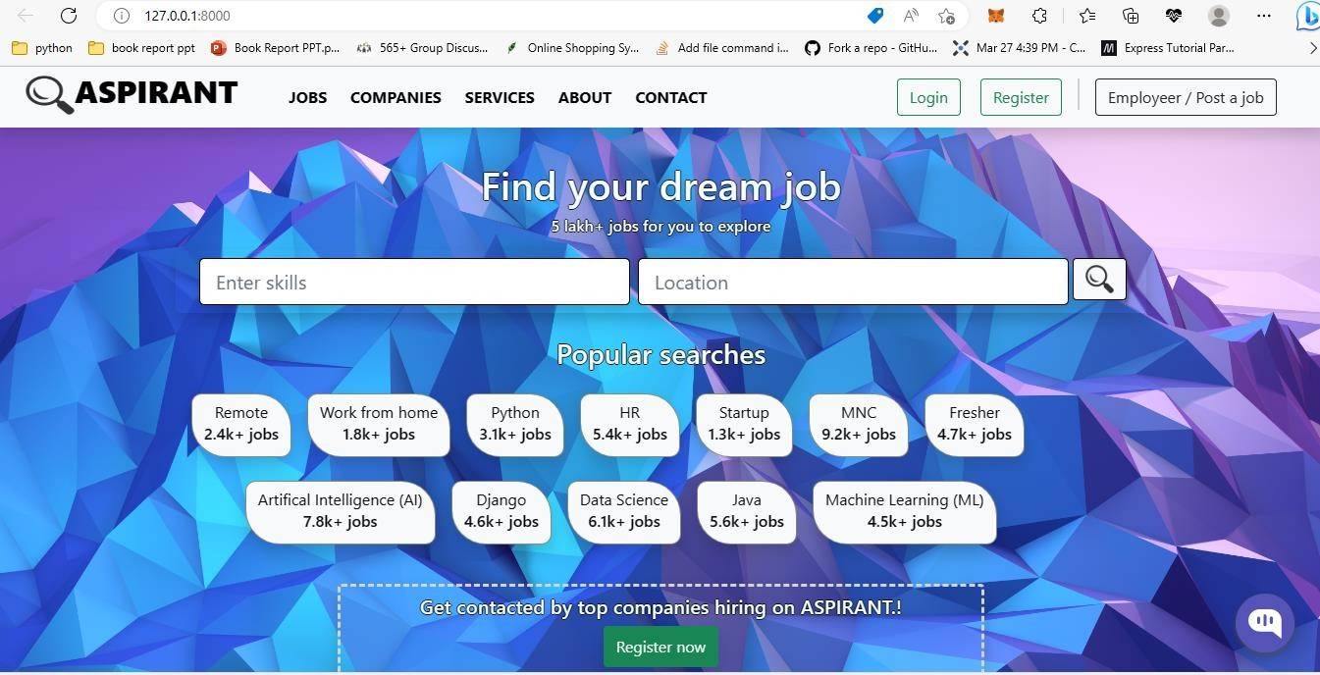

* + 1. **Dashboard Page**

Fig 5.2.1 shows the dashboard page which will be shown to the user after visiting the website. In this it shows filtering option of job searches like job location, job sites based on skills and company requirements.

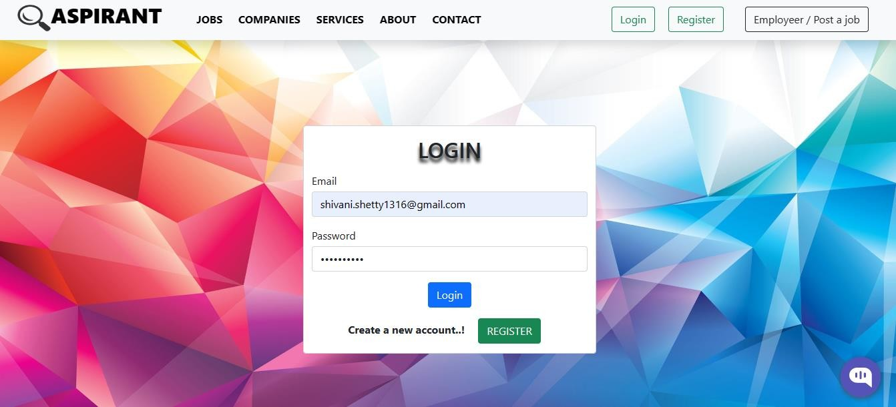

* + 1. **Login Page**

Fig 5.2.2 shows the Login page where the user needs to enter the details like email and password and register option so they can review and access the login and registration process.

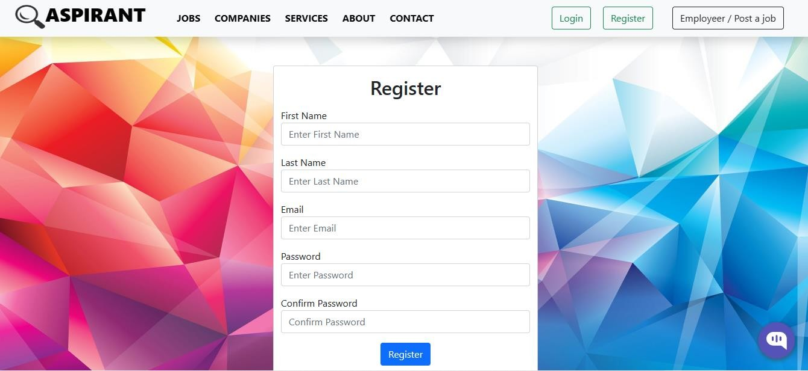

### Register Page

Fig 5.2.3 shows the Register page where user need to enter the information.after visiting the website the user first needs to enter the required details and other information to register on the platform.

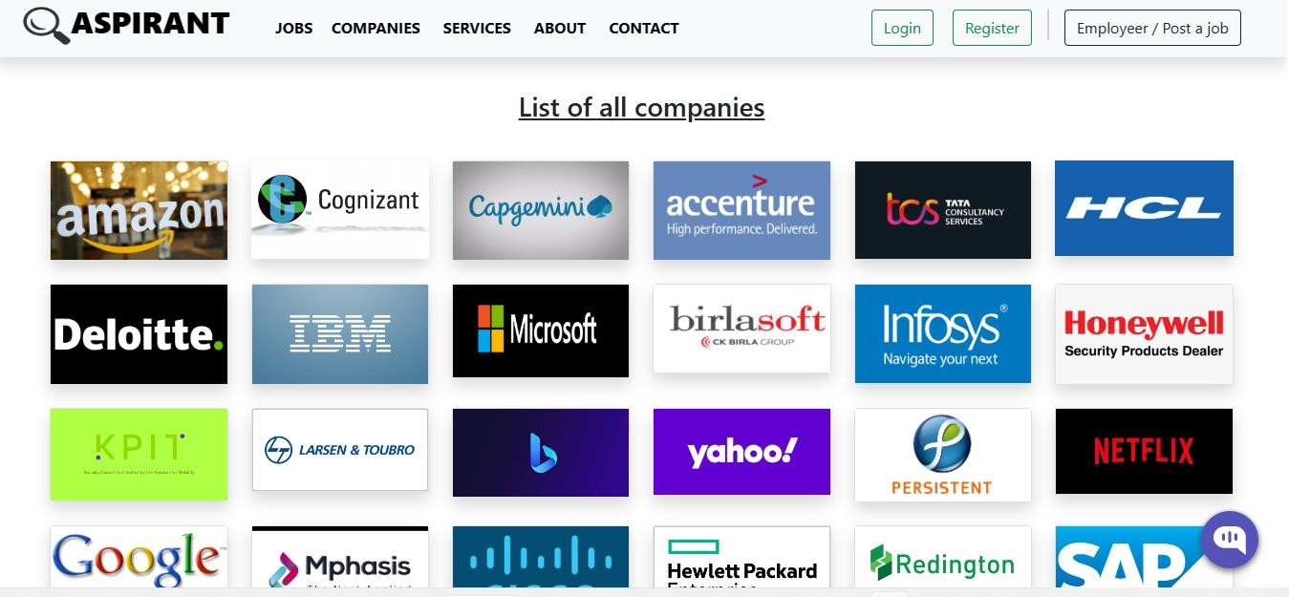

### List of Companies

Fig 5.2.4 shows the list of companies which are present or connected to the portal. After clicking on that company image it redirects to the company official page.

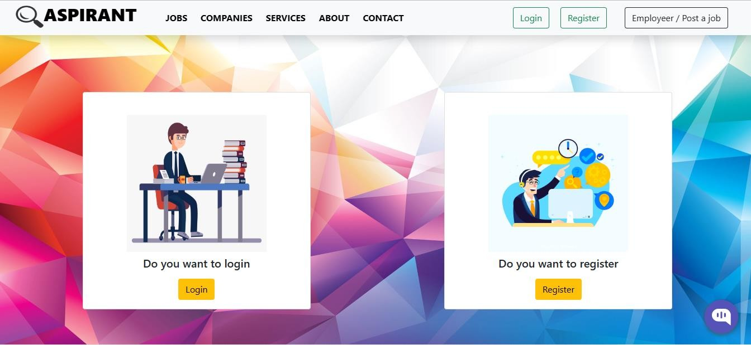

### Company posting job page

Fig 5.2.5 shows the page where company first login and register after creating the account successfully they can post a job for recruiting the job seekers.

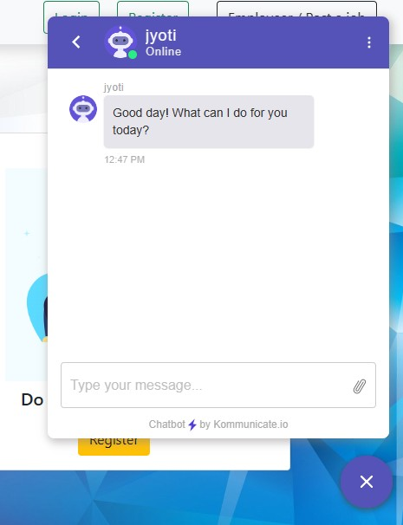

### Chatbot

Fig 5.2.6 shows the Chatbot where user can ask their queries about the resume ticks and company registration form links. It has conversational rating option to rate the conversation with the chatbot helper.

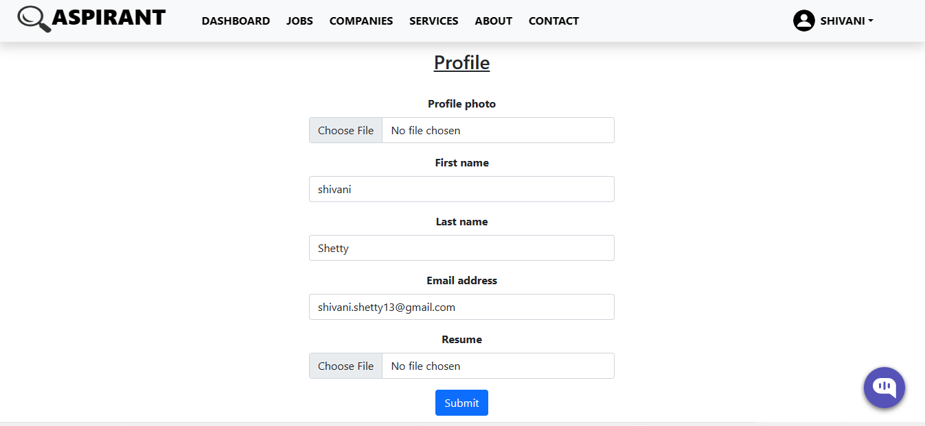

### Profile Making

Fig 5.2.7 shows the Profile page, where user has to make their profile by entering above details that is resume file upload, profile image and personal details.

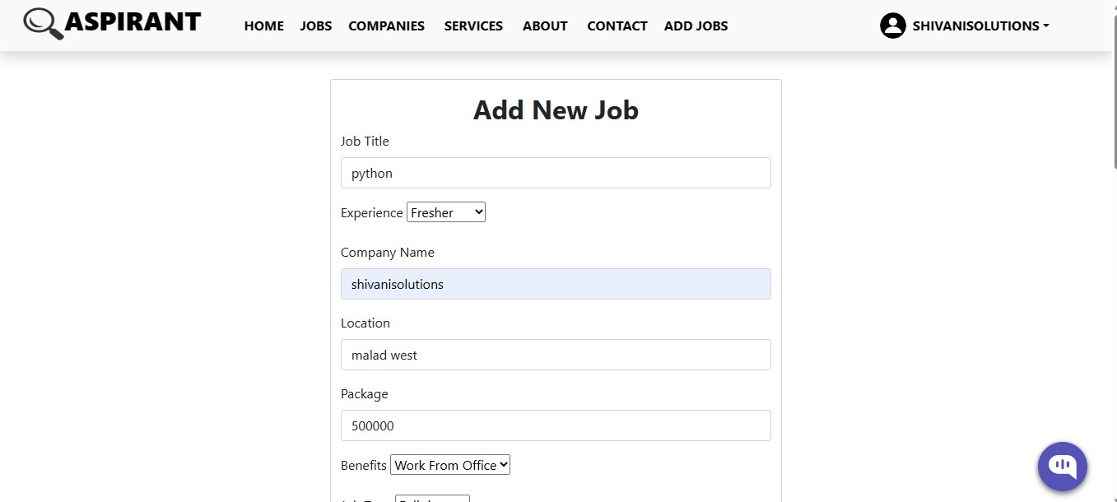

### Adding New Job

Fig 5.2.8 shows that the employee of the company can add new job vacancy post for different posts in their company. It also add the details of benefits, location, date of post, expiry date of the job application.

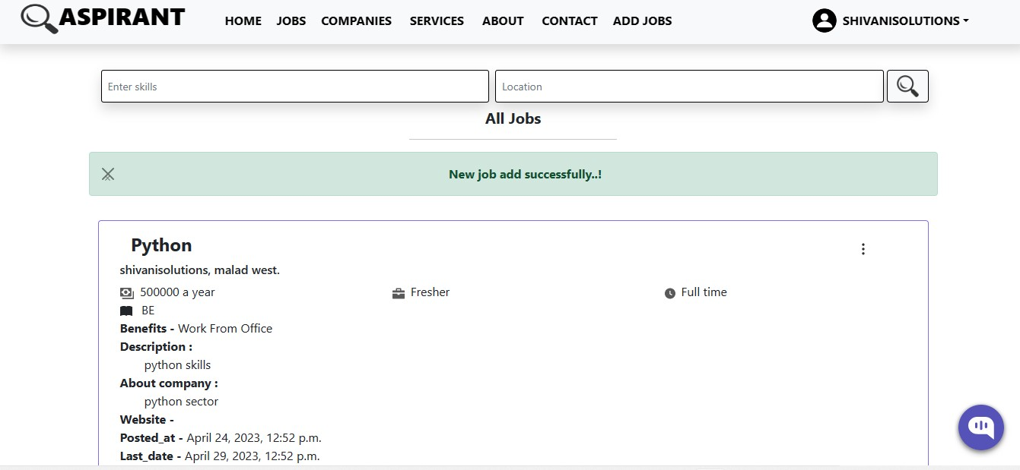

### List of Jobs

Fig 5.2.9 shows the List of Jobs available on the website on user side portal when the employer of the company post a job on the portal.

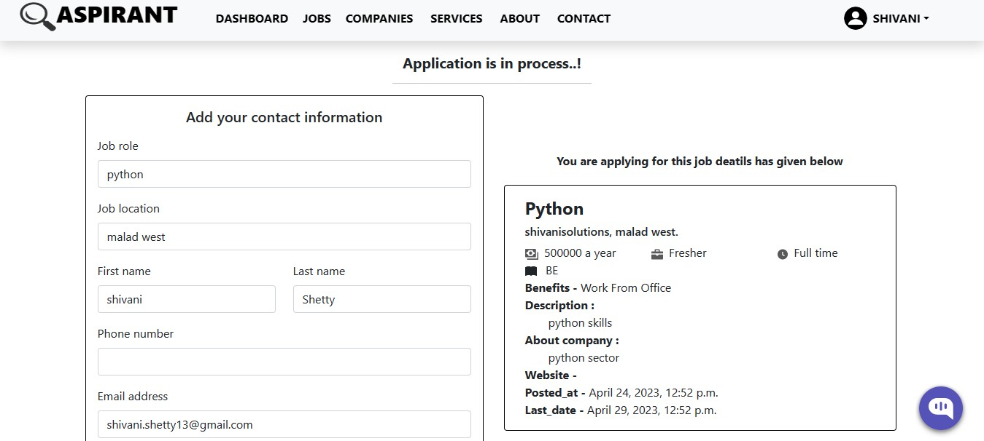

### Application to the Company

Fig 5.2.10 shows that user can apply to the company by applying the application form for a particular job position based on user preference.

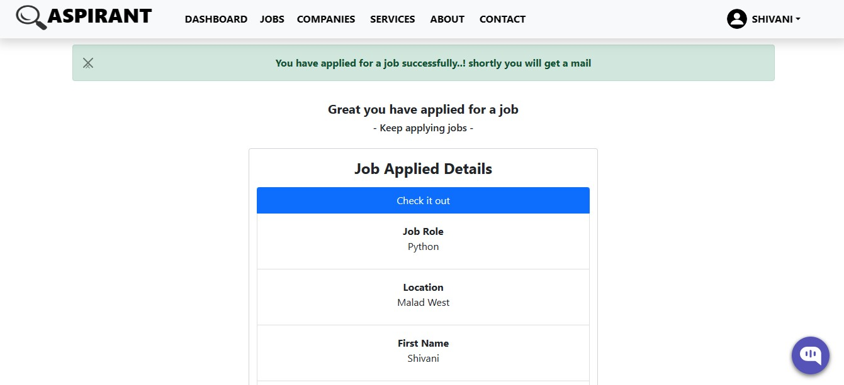

### Job Application Status

Fig 5.2.11 shows the Application status after successfully applied the application form for a particular skill based job of user preference with their resume. It shows the confirmation of successful application.

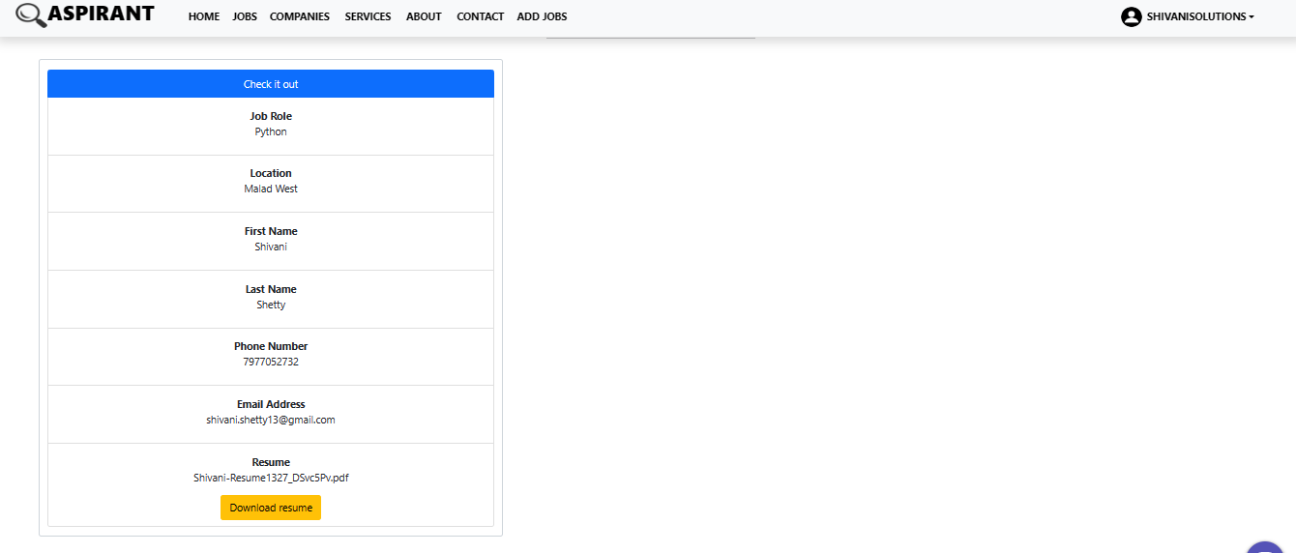

### Checking Applicant’s

Fig 5.2.12 shows that company can view or check how many applicants have applied for the job which the company had posted. It shows all the detail information that the user applied in the form. The company can view the resume and download it.

## CHAPTER 6 : CONCLUSION

We have designed and implemented an “Online Job Portal” application that caters the needs of a job seeker as well as an employer. This portal provides all the features with the provision of extension of python pip extensions. The plugin, we used a free trial, so its functionalities are limited. In this web-based application, we have implemented various features such as filtering for different jobs, application to company, resume uploading and saving, resume rating, chatbot etc. This project is aimed at developing an online search portal for job seekers. With the Online Job Search Portals, the recruitment process is speeded up at every stage from job postings, to receiving applications from candidates. No matter where you are, you can send out the job posting anytime with the internet access. The main aim of this portal is to attempt to produce the fair candidates based on the in-company’s needs.

# CHAPTER 7 : FUTURE SCOPE

Our future scope for this “Online Job Portal” is confirmation mail after successful application that will give clear view to candidates that they are selected or not. There have been many uses of online job portal .The other one is application-based portal used by job seekers on their mobile device and Resume Subscription. This are the future scope of our project.

## REFERENCES

1. Yadav, U. Gewali, S. Khatri, S. R. Rauniyar and A. Shakya, "Smart Job Recruitment Automation: Bridging Industry and University," 2019 Artificial Intelligence for Transforming Business and Society (AITB), Kathmandu, Nepal, 2019, pp. 1-6, doi: 10.1109/AITB48515.2019.8947445.
2. Marjan Mansourvar and Norizan Binti Mohd Yasin, “Development of a job web portal to improve education quality,” International Journal of Computer Theory and Engineering, Vol. 6, No. 1, February 2014.
3. O. Shafique, “Recruitment in the 21st century”, Interdisciplinary Journal of Contemporary Research in Business, Vol. 4, No. 2, 2012, pp. 887-901
4. V. K. Sehgal, A. Jagtiani, M. Shah, A. Sharma, A. Jaiswal and D. Mehta, "Job Portal - A Web Application for Geographically Distributed Multiple Clients," 2013 1st International Conference on Artificial Intelligence, Modelling and Simulation, Kota Kinabalu, Malaysia, 2013, pp. 199-204, doi: 10.1109/AIMS.2013.38.
5. M. Gangle, “The only way is up? Employment protection and job mobility among recent entrants to European labor markets,” European Sociological Review, vol. 19, pp. 429, 2007.
6. M. Mansourvar and N. B. M. Yasin, “Knowledge portal: a tool to capture university requirements,” in Proc. 2011 International Conf. on Graphic and Image Processing, International Society for Optics and Photonics, October 2011, pp. 82850F-82850F

# PAPER PUBLICATION

|  |  |  |  |
| --- | --- | --- | --- |
| **SR.**  **No** | **JOURNAL NAME** | **AUTHORS** | **YEAR OF PUBLICATION** |
| 1 | International Journal of Scientific Research in Engineering and Management. (IJSREM) | Dr.Roshani Bhaskarwar , Nikita Kumthekar , Daivashree Kokate, Shivani Shetty, Jyoti  Some | March 2023 |

25



**International Journal of Scientific Research in Engineering and Management (IJSREM)**

**Volume: 07 Issue: 04 | April - 2023 Impact Factor: 8.176** ISSN: 2582-3930

**Online Job Portal**

Daivashree Kokate¹ Nikita Kumthekar² Shivani Shetty³ Jyoti Some⁴

[daivashreekokate@gmail.com](mailto:daivashreekokate@gmail.com) [nikitakumthekar01@gmail.com](mailto:nikitakumthekar01@gmail.com) [shivani.shetty1316@gmail.com](mailto:shivani.shetty1316@gmail.com) [jyotisome70@gmail.com](mailto:jyotisome70@gmail.com)

Dr. Roshani Bhaskarwar⁵

[roshani.bhaskarwar@dmce.ac.in](mailto:roshani.bhaskarwar@dmce.ac.in)

¹²³⁴7 Department of Information Technology, Datta Meghe College of Engineering, Arioli, India

***Abstract - Now a day’s, it is difficult to search for jobs in proficient areas, so this online job portal is developed to provide the simple and efficient job searching. So Online Job Search Portal is a web-based and android application, which revolutionizes the way companies hire the candidates and jobseekers search for job vacancies. The application provides a flexible and easy to use environment on desktops as well as portable devices like smart phones/tablets for the users to achieve their respective objective. An employer being registered in the web site has the facility to use the services. Being an authorized user, he can publish vacancy details and can search number of Employees on the portal. Also, he can search candidates on basis of the key skill which employee provides on registration. The employer can rate the resume uploaded by the jobseeker. Candidates can search for jobs in various IT domains through advanced search capabilities. They can upload their resumes to this application which is stored for future use also. The admin controls this portal and makes the decision about companies and jobs that can access/appear in this portal. Chatbot is also provided in our website where the jobseeker can have a conversation with the bot facing any issues while registration process or also the bot can provide some tips and tricks for resume building process. These features help to build a user-friendly job portal.***

***Keywords - Companies, Feedback, Job Portal, Jobs, Results, Skills.***

* 1. **INTRODUCTION**

Before the invent of other various technologies and methods that were used in the past for hiring people for the job were advertisements through newspaper, television, radio etc. [1]. These traditional methods were too slow, difficult and demanding for the people. This way of hiring people was not effective. Due to advanced technologies many websites emerged. As of Indian market, there are ample opportunities for the jobs, as a greater number of educated and skilled young people are graduating each year. So, it is now the right period for the job portal sites to think out of the box, and to make most

of the opportunities available. With the help of this portal the

job seeker can easily submit their resume and get a lot of opportunities of the job related to their profile. And by this website the companies or employer can also find the good and

well profiled resume**.** The online job Portal System that is to be developed provides the members with jobs information, online applying for jobs and many other facilities. This system provides services to the job applicants to search for working opportunities. Job Portal will allow job provider to establish one to one relationship with candidates. This Portal will primarily focus on the posting and management of job vacancies. This system is designed such that ultimately all vacancies will be posted online and would offer employers the facilities to post their vacancies online. It helps to review and manage the resulting applications efficiently through the web.

* 1. **RELATED WORK**

For this job portal we searched different surveys on internet based on various features and services. People nowadays spend more time on internet. Internet has become a trustworthy tool for everyone for the one who is seeking for better job.

Marjan Mansourvar and Norizan Binti Mohd Yasin mentioned in their paper that people use online methods which are suitable and saves a lot of time [2]. There are various websites for people to get knowledge about the job- related information.

O. Shafique described that E-Recruitment system is very useful for college students to find a suitable jobs. Interviews are also the best way to find the candidate for the job. Effective e- recruitment process helps job seekers to find their choice jobs. Cost effective job portal is very important in colleges that help more students getting hired. Building such proper recruitment application need prior study of current situation and environment to know in more proper way we need to study deeply each concept thoroughly [3].

V. K. Sehgal claimed that there is another way to wherein we can develop a knowledge system that acts as a job portal that helps in more enhancement of the services and features. It can be divided into three areas of improvements that is graphical, contents and technical [4].

Gangle stated in the paper that the online recruitment

**© 2023, IJSREM |** [www.ijsrem.com](http://www.ijsrem.com/) **DOI: 10.55041/IJSREM18565** | Page 1



**International Journal of Scientific Research in Engineering and Management (IJSREM)**

**Volume: 07 Issue: 04 | April - 2023 Impact Factor: 8.176** ISSN: 2582-3930

process has lots of advantages that is employers can identify many eligible job seekers and get their information easily. This process helps employers to upload the job vacancy on the portal and jobseekers can view it and send their resume this saves time and cost [5].

M. Mansourvar and N. B. M. Yasin conveyed that the main features to improve and enhance the online job portals are to provide job offering services that can help job seekers to find all information about job vacancies. Job offers can be matched with job seekers profiles about their qualifications and skills. In this way job portals can show similar match job vacancy posts. It can show email alerts of jobs, send resumes to the website and also can have online contact with the individual job seekers. These are the new advanced ways that can be applied and modified to the online job portal and user friendly for job seekers to find their dream job. [6]

The proposed system has been mainly designed to overcome some of the problems faced with the previous system. In previous systems they didn’t have features like chatbot, resume rating, chatbot conversational rating etc. And other problems such as:

1. Most jobseekers do not have enough basic knowledge. on how to select a specialized job available.
2. Job seeker expectations in terms of job specifications are sometimes different from that of the company.
3. Many new graduates, who become unemployed because they do not have the job skills needed by the industry, pose a big challenge for any country in the world.

DESIGN OBJECTIVES

This paper aims to develop a web portal that will allow the employer companies to share relevant data and information with job aspirants, as well as to make available information on online-recruitment.

The objectives of this project are:

1. To design, implement and develop a simple convenient web portal.
2. To identify the needs of the companies and job seekers which will be incorporated with updated information.
3. To understand the meaning, features and categories of web portals.
4. To design an online recruitment system that allows employers to post their job advertisements, which job seeker can refer to, when looking for jobs. This job portal can capture job requirements based on industry needs.
   1. **PROPOSED SYSTEM STRUCTURE**

Based on information from the literature review, as well as the identified job aspirants’ requirements, a new web job portal was proposed. This portal is for the job seekers and employers. The main aim for designing this system is to achieve the

objectives of this study. The job seekers’ requirements for the new portal were identified from the findings of the surveys, discussed previously. The new portal serves as a web-based tool which caters to the needs of students and users who are already employed as general users; unemployed as the job seekers in the system, and organizations as the employers. The admin is considered as a different category of user that manages, controls, and views the whole process in the system.

Figure 3.1 shows the external schema of the web portal framework. This framework is for Job Web Portal in which the web portal consists of Admin, Company, User. The flow of our project is first it shows user login process then showing the jobs for domain and option for various companies. It comprises of two main logins that is user and admin. Admin is the backend process of this job portal. It shows all information of user in database form. Company sites links are shown for user to easily view the company profile.

Users task in this job portal is to login, upload resume and apply for jobs.

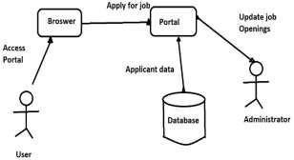

Fig.3.1 The Proposed Framework for Job Web Portal.

According to the objectives of this study, this portal also acts as a management system, which provides information to job seekers to help them in selecting desired future careers. Also, this system should contain information about the industries. Hence, the importance of having a job portal that shares knowledge and provides information is highlighted. This section of the portal design provides information about the different job vacancies which are offered by companies and how they relate to future jobs in the industry. A portal is a website which presents online information and services to its users. In addition, this portal can be a suitable medium for the job seekers to establish a link with the employers or HR managers. Moreover, this portal which provides updated information about the job vacancies and other related topics is a good way to satisfy the job seekers’ requirements. A main feature of this portals is the sharing of information from authenticated or authorized sources.

This section of the portal is open for users and will be more helpful, especially, for the students who are deciding to choose the major and selecting the courses to study and how the courses they take can affect the type of jobs, in future. In designing a system, the functional requirements reflect a set of inputs, the



**International Journal of Scientific Research in Engineering and Management (IJSREM)**

**Volume: 07 Issue: 04 | April - 2023 Impact Factor: 8.176** ISSN: 2582-3930

actions, and the outputs of the system. They define the reactions of the designed system in different situations. The developed portal also acts as a job portal which help fresh graduates and final year job seekers to search for jobs has three sections- Admin, users, and companies.

* 1. **WORKFLOW**

The data flow schema of the proposed web portal is illustrating the relationship between the job seekers or employee, the potential employers and an admin is shown in Figure 4.1

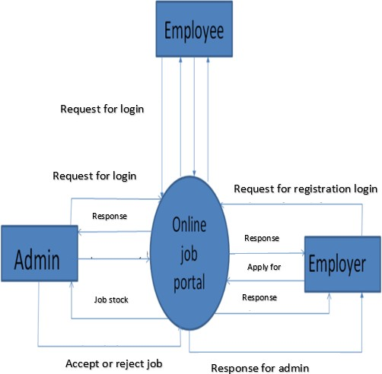

Fig.4.1 Data Flow Diagram (Context Diagram)

The detailed workflow of this application is as follows:

* 1. **Generic:**

1. Login to the system through the first page of the application
2. Change the password after login to the application.
3. See his/her details and change it.
4. Help from the system.
   1. **Employer:**
5. Should be able to create a new vacancy.
6. Should be able to change any of the editable details for the vacancy.
7. Should be able to create a new applicant.
8. Should be able to change any of the editable details for the applicant.
9. Attach an applicant to a vacancy - *The relationship between applicant and vacancy should be many: many.*
10. Should be able to schedule the interview and enter details of the interviewer and date/time.
11. Should be able to postpone or remove the interview.
12. The HR person cannot ‘close’ the vacancy which is not owned by them.
    1. **Admin:**
13. Should be able to create a new applicant.
14. Should be able to change any of the editable details.
15. Attach an applicant to a vacancy.
16. The relationship between applicant and vacancy.
    1. **Employee:**
17. Should be able to view all vacancies scheduled taken.
18. Should be able to view the details of the company.
19. Should be able to view the details of the vacancy.
20. Should be able to search for vacancies.
    1. **REQUIREMENT ANALYSIS**
21. Hardware Requirement
    1. Intel Quad core 2.30 GHZ Processor or above.
    2. Minimum 100 GB HD.
    3. Minimum 4 GB of RAM.
    4. Standard Keyboard and Serial Mouse.
22. Software Requirement
    1. Django Framework
    2. Python 3.10
    3. SQLite3 (Database)
    4. Visual Studio Code (Interpreter)
    5. Bootstrap & CSS (GUI)
    6. **IMPLEMENTATION AND RESULT**

In this web-based application, we have implemented various features such as filtering for different jobs, application to company, resume uploading and saving, resume rating, chatbot etc. This project is aimed at developing an online search portal for job seekers.

* 1. **ADMIN**

Django provides the admin login. The admin module provides various functionalities. The admin users are responsible for activating and deactivating the employer accounts. In addition, Admin users can view the list of employers registered with the



**International Journal of Scientific Research in Engineering and Management (IJSREM)**

**Volume: 07 Issue: 04 | April - 2023 Impact Factor: 8.176** ISSN: 2582-3930

application.

* 1. **EMPLOYER**

Employer users will be able to perform functions such as registering with the application and creating an account by providing the details of Employer Name, Employer Code, Address, Company Email, Mobile Number, Login Name. Also, Passwords that are stored in the Employer table of MySQL database. Once the account is activated, this module allows employers to post jobs summarizing responsibilities and expected skills that will be saved in the Posted Jobs table of MySQL database. The employer will also be given privileges to activate or deactivate jobs. He/she can view the list of job postings that are active. He/she can also view the applicant details that have applied for a particular job posting. The employer will be able to view reviews provided by the jobseeker.

* 1. **JOBSEEKER**

The Jobseeker users will be able to perform functions such as registering with the application and creating an account by providing the details of First Name, Last Name, E-mail, Password, Mobile Number, Primary Skill, and Experience that are stored in the Jobseeker table of MySQL database. Once the account is activated, jobseekers can search, view, and apply for active job openings. All the applied jobs details are stored in the applied jobs tables of MySQL database. The applicants can also write/update reviews for the companies.

* 1. **FILTERS FOR DIFFERENT JOBS**

In the Online Job Portal System, after successfully registering and login procedure, the system will help the user to create an account on the portal. With the help of filtering process, the user will get to search any parameter like job post, or location in the search box on the dashboard page on the portal.

* 1. **APPLICATION TO COMPANY**

After applying to the company, the respected message will be shown to the user whether the application to the company is successful or not. This feature enables the user to apply and confirm the application to the company or organization.

* 1. **RESUME UPLOADING AND SAVING**

While applying to the particular company the company asks to upload the resume of the candidate to the user. In the Online Job Portal, a user can upload their resume in doc, pdf, or jpg format also. And the uploaded resume gets saved on the system. The employer can also save the resume for the future use.

* 1. **RESUME RATING**

As the jobseeker registers in our portal, they can start uploading their resumes for the recruitment such that the employer goes through their resumes thoroughly eventually if any employer likes or dislikes the employee’s resume they can rate the resume and also can write a comment regarding the same.

* 1. **CHATBOT**

Here we provide a chat bot feature where the applicant can be

able to chat with the bot such that it can give some of the guidance for the process. example guidance for resume building, applying for different jobs. The bot can provide tips and tricks for resume building process. Which will help the jobseeker for the recruitment in the future.

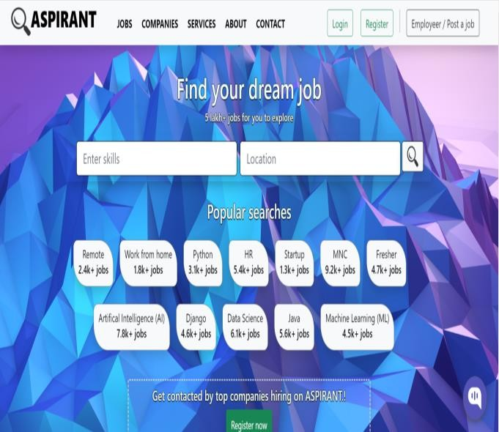

Fig.6.1. Dashboard Page

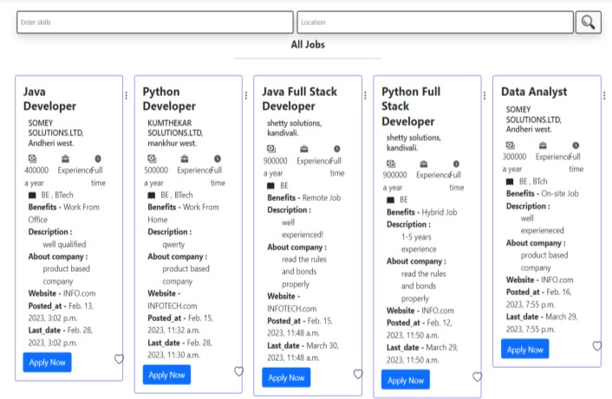

Fig.6.2. list of all Jobs Page

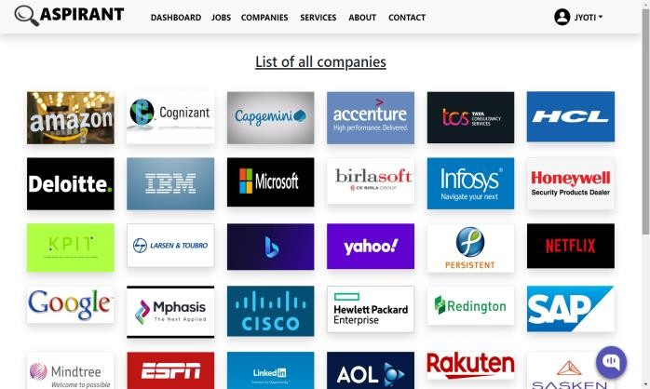

Fig.6.3. List of Companies Page



**International Journal of Scientific Research in Engineering and Management (IJSREM)**

**Volume: 07 Issue: 04 | April - 2023 Impact Factor: 8.176** ISSN: 2582-3930

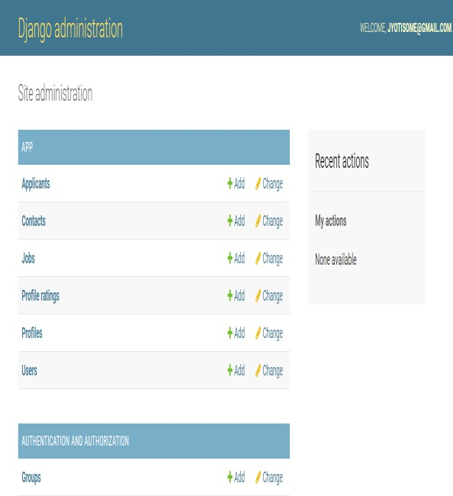

Fig.6.4. Admin Page

* 1. **CONCLUSION**

We have designed and implemented an “Online Job Portal” application that caters the needs of a job seeker as well as an employer. This portal provides all the features with the provision of extension of python pip extensions. The plugin, we used a free trial, so its functionalities are limited. In this web-based application, we have implemented various features such as filtering for different jobs, application to company, resume uploading and saving, resume rating, chatbot etc. This project is aimed at developing an online search portal for job seekers. With the Online Job Search Portals, the recruitment process is speeded up at every stage from job postings, to receiving applications from candidates. No matter where you are, you can send out the job posting anytime with the internet access. The main aim of this portal is to attempt to produce the fair candidates based on the in-company’s needs.

**REFERENCES**

1. V. Yadav, U. Gewali, S. Khatri, S. R. Rauniyar and A. Shakya, "Smart Job Recruitment Automation: Bridging Industry and University," 2019 Artificial Intelligence for Transforming Business and Society (AITB), Kathmandu, Nepal,2019, pp.1-6, doi: 10.1109/AITB48515.2019.8947445.
2. Marjan Mansourvar and Norizan Binti Mohd Yasin, “Development of a job web portal to improve education quality,” International Journal of Computer Theory and Engineering, Vol. 6, No. 1, February 2014.
3. O. Shafique, “Recruitment in the 21st century”, Interdisciplinary Journal of Contemporary Research in Business, Vol. 4, No. 2, 2012, pp. 887-901
4. V. K. Sehgal, A. Jagtiani, M. Shah, A. Sharma, A. Jaiswal and

D. Mehta, "Job Portal - A Web Application for Geographically Distributed Multiple Clients," 2013 1st International Conference on Artificial Intelligence, Modelling and Simulation, Kota Kinabalu, Malaysia, 2013, pp. 199-204, doi:

10.1109/AIMS.2013.38.

1. M. Gangle, “The only way is up? Employment protection and job mobility among recent entrants to European labor markets,” European Sociological Review, vol. 19, pp. 429, 2007.
2. M. Mansourvar and N. B. M. Yasin, “Knowledge portal: a tool to capture university requirements,” in Proc. 2011 International Conf. on Graphic and Image Processing, International Society for Optics and Photonics, October 2011, pp. 82850F-82850F.

**CERTIFICATION**

